Arduino Lesson 14
Fire Alarm
- Intro

Flame sensor (i.e., the infrared receiving triode) are specially used to search for the fire source in robot, this sensor is particularly sensitive to the flame
How it work?
Infrared is very sensitive to flame, use special infrared receiving tube to detect fire, and then turn the flame brightness into high and low level signal, input the signal to the central processor, the central processor will react according to the change of signal.
Connection?
- The short pin is cathode, long pins is anode.
- Connect the cathode to 5v interface and anode with 10kΩ resistor as below picture shown, the other end of the resistor connect to GND interface
- Access the anode of flame sensor positioned column to analog port #5 with a jumper wire
- Connect the buzzer as lesson 2 shown.
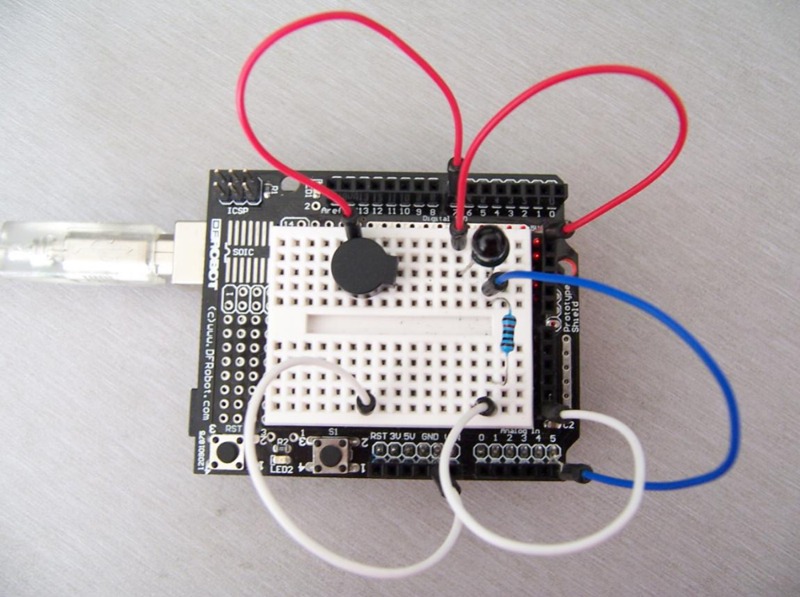

Below picture for reference

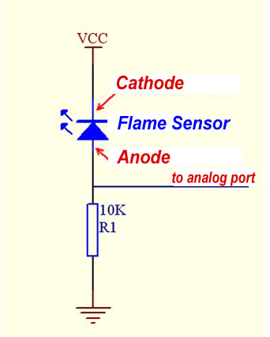
Parts required
 Flame Sensor x 1
 Buzzer x 1
 10KΩ Resistor x 1
 Jumper wires x 1Bundle

Experiment Theory
The voltage value from analog port is changing by the distance between flame and sensor. A AVO meter read about 0.3v without flame approached. When flame is approaching,voltage reading is about 1.0 V, closer to the flame, the bigger the voltage is.Before we start, we can store a value (voltage) i.e “I”, then keep reading the voltage value from analog port, i.e “j”,make the differential as “k” = j-I and compare with 0.6v. Set the buzzer to make a sound when the differential >0.6v, if not, buzzer not make sounds.
- Program for reference
int flame=A5;//Define flame interface as analog interface #0.
int Beep=8;//Define buzzer interface as digital interface #7.
int val=0;//Define digital variables.
val void setup()
{ pinMode(Beep,OUTPUT);//Set LED as output
pinMode(flame,INPUT);//Set buzzer as input
Serial.begin(9600);//Set baud rate as 9600
}
void loop() { val=analogRead(flame);//Read the analog value
from flame sensor
Serial.println(val);//Output analog value and print it out if(val>=600)//When analog value 〉600，buzzer make sound
{ digitalWrite(Beep,HIGH); } else { digitalWrite(Beep,LOW); } }

Download the program as Arduino tutorial shown

